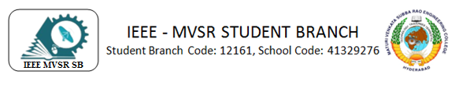

5 DAY WORKSHOP ON SOLAR PV PLANT DESIGN

IEEE MVSR PES Student Chapter in collaboration with EESA has conducted a 5-day workshop on solar PV plant design for the electrical and electronics students of the third year from 3rd to 7th of October 2023. The main motto of this workshop is to give an overview of solar systems, PV system components selection, Rooftop PV plant design, solar plant visits, and training on PV systems.

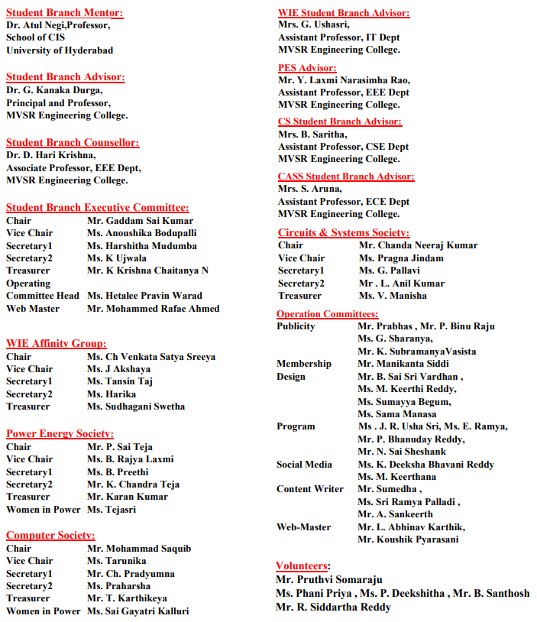

Session Details:
Date: 3 to 7 October, 2023.
Timings: 09:30 am-4:15 pm.
Number of Attendees: 92, IEEE: 13 and Non-IEEE: 79
Speaker of the Session:

Mr. Madan Mohan, CEO, of HIEE, has 16+ years of experience in the design of Switch Gear Panels, Sub Stations, and Solar Applications.

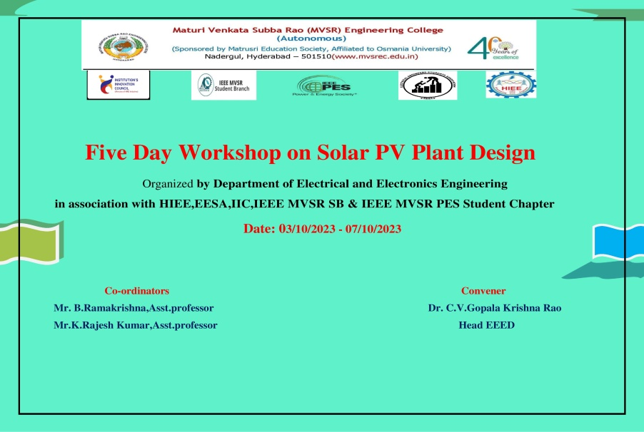

Poster of the five-day workshop on Solar PV Plant Design

1st day: 3rd October, 2023
On 3rd October 2023, Mr. B. Rama Krishna, Asst commenced the session. Professor, EEE Department by welcoming Dr. C.V. Gopala Krishna Rao, Head-EEE Department, Mr. Madan Mohan HIEE, CEO, Dr. D. Hari Krishna, Student Branch Counsellor & Associate Professor, EEED, Mr. Y Laxmi Narasimha Rao IEEE MVSR PES Student Chapter Faculty Advisor and all the faculty and student participants. Later, Dr. C.V. Gopala Krishna Rao addressed the gathering, explained how renewable energy sources are important nowadays, and explained that one of the most important renewable energy sources is solar and the importance of Solar PV Plant Design.
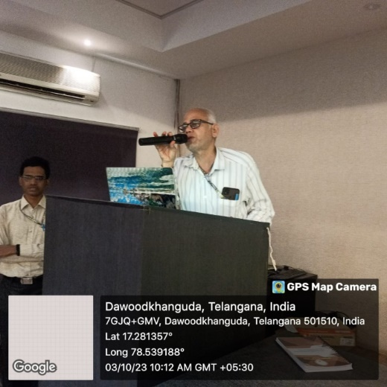
Dr. C. V. Gopala Krishna Rao sir addressing the gathering on 1st day

In continuation, Dr. D. Hari Krishna addressed the gathering about the importance of Solar PV Plant Design in today’s scenario and the advantages of IEEE PES membership. Later handed over the session to Mr. Madan Mohan, CEO, of HIEE. Mr. Mohan started his session with an overview of how the solar system is evolving in India, key market trends in utility-scale and Rooftop Segments, Rooftop Solar, How it works, Site analysis, and rooftop and utility solar readiness assessment. Later he gave students, some assessment questions to solve. He also explained the career opportunities in Solar PV Plant Design. The first-day session concluded with a recap of all the topics covered.

2nd day: 4th October, 2023
On the second day, Mr. Mohan started the session with the introduction of the components selection of the Photo Voltaic Cell. Later he gave a detailed explanation of the Technical overview of DC and AC principles of Solar PV Systems, different types of panels, inverters, and other balances of the system, components for both Off-Grid, On-Grid, and utility-scale, and evaluation of PV modules mounting structures. Later he gave students, some assessment questions to solve. A recap of all topics discussed this day marked the end of the second-day session.

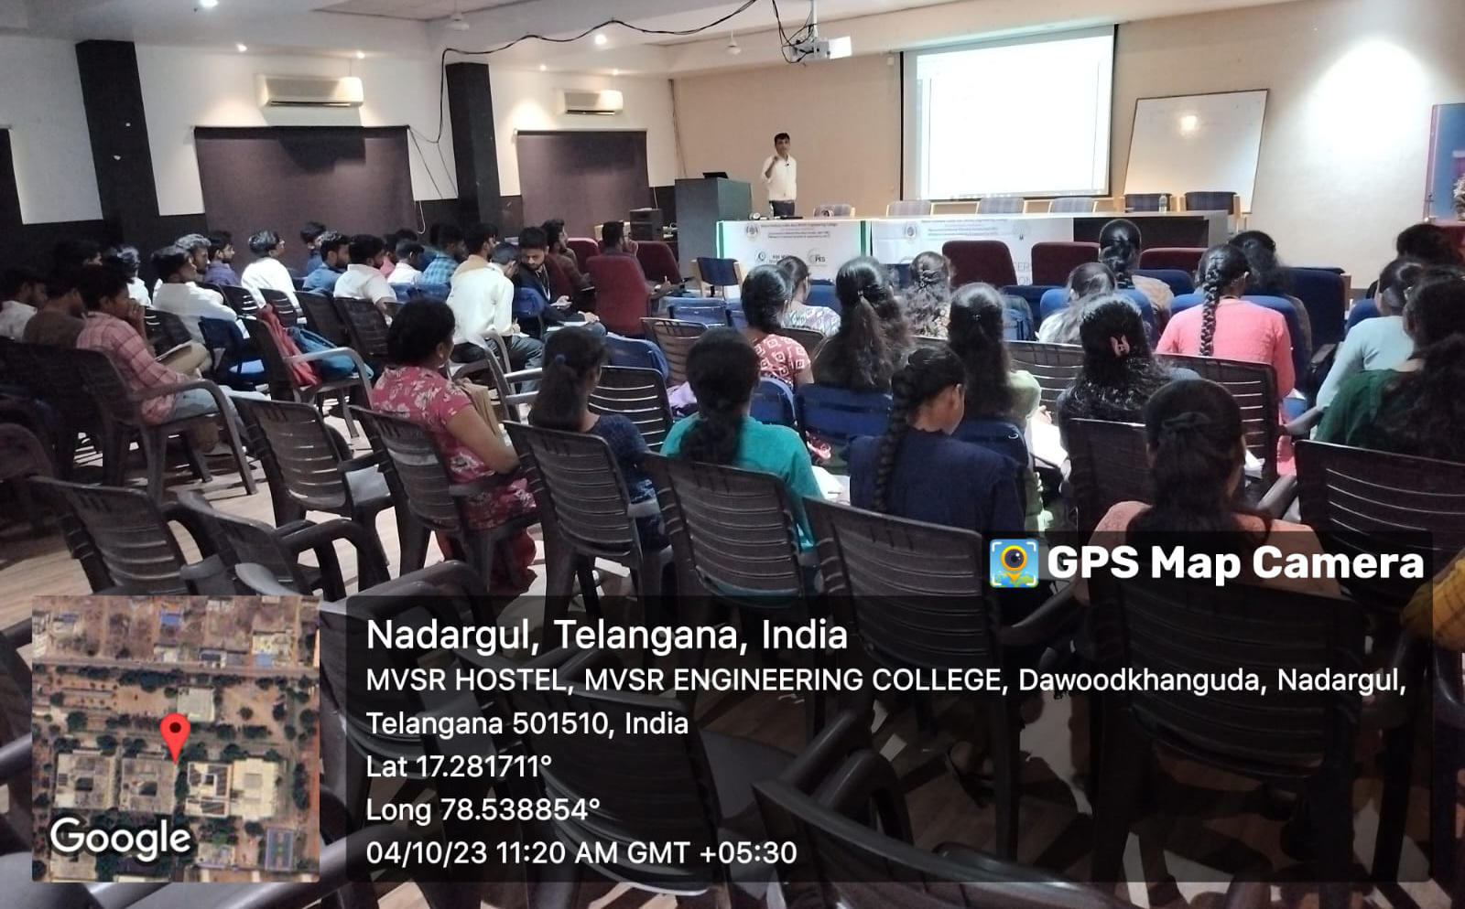
Speaker addressing the gathering on 4th October, 2023

3rd day: 5th October, 2023
On the third day of the workshop, Mr. Mohan started the session with an introduction to Rooftop PV Plant Design which involves string selection, DCDB and ACDB design and selection, single-line diagram preparation, cable sizing, PV Power Evacuation, and Net Metering concept. He also gave some assessment questions on these topics to calculate strings etc. Later he asked students, to solve some assessment questions. The third-day session came to an end with a recap of all topics discussed on that day.

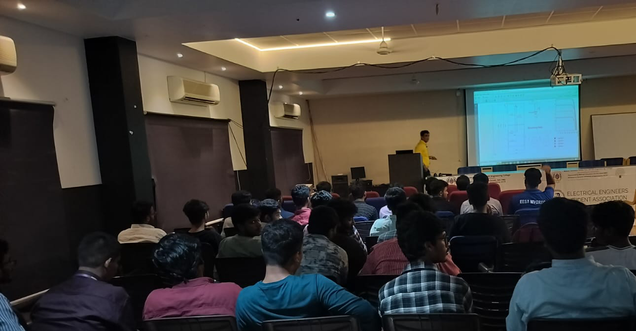
Speaker addressing the gathering on 5th October, 2023

4th day: 6th October, 2023
On the fourth day of the workshop, there was a visit to the solar plant which is located on the rooftop of CSED, MVSREC. He advised the student to observe the solar plant and count the connected modules, determine the capacity of the plant, and how many inverters are required for this plant. Then he showed and explained about the inverter which is connected to the solar plant. He also explained in detail about the inverter, cable sizes connected to the inverter, inverter capacity, and many more technical aspects of the solar plant.

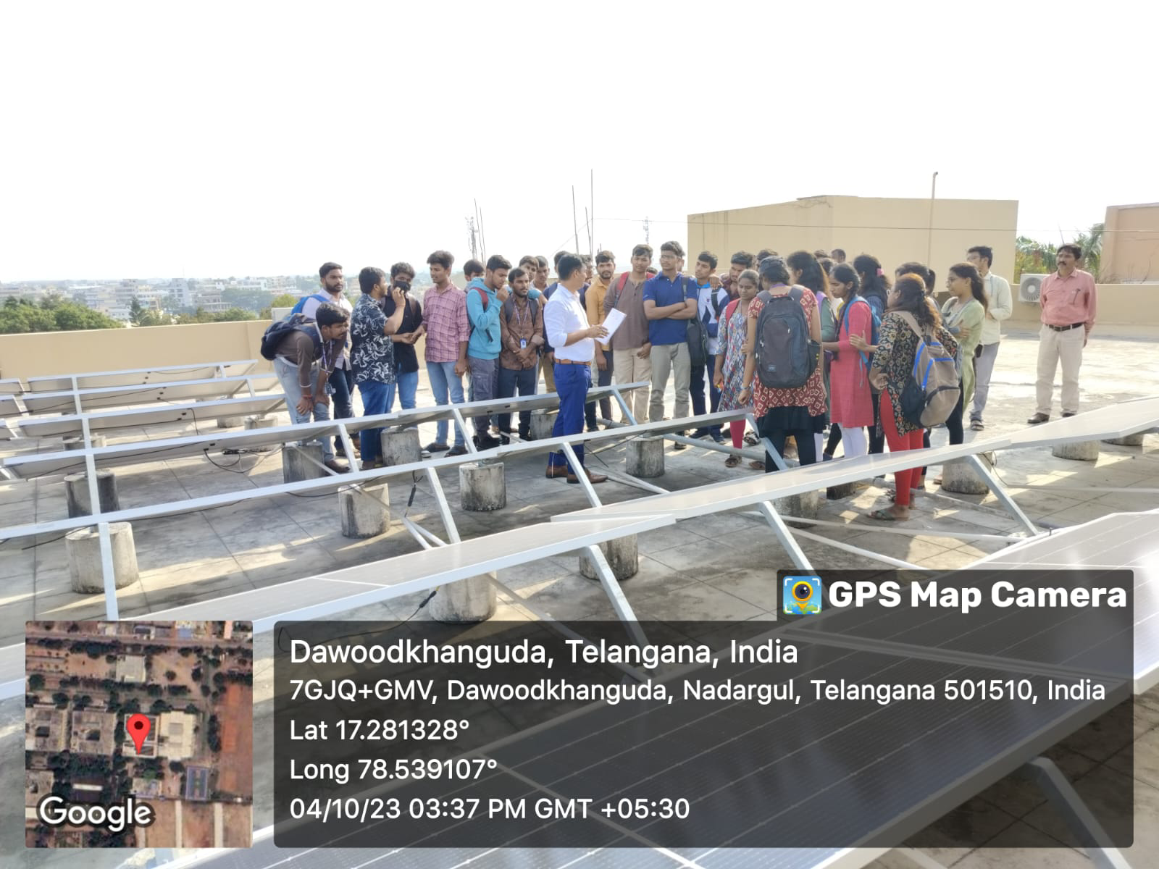
Solar PV Plant visit on the rooftop of CSED, MVSREC.

5th day: 7th October, 2023
On the fifth day of the workshop, the session started with the introduction of PV system software. He told the importance of PV system software for analysis of power extraction from solar plants, he also gave training on PV-system software which includes site selection, module orientation, system configuration, and energy generation report. He also gave some site information and asked the student to generate a report on those sites and asked how much energy had been generated.

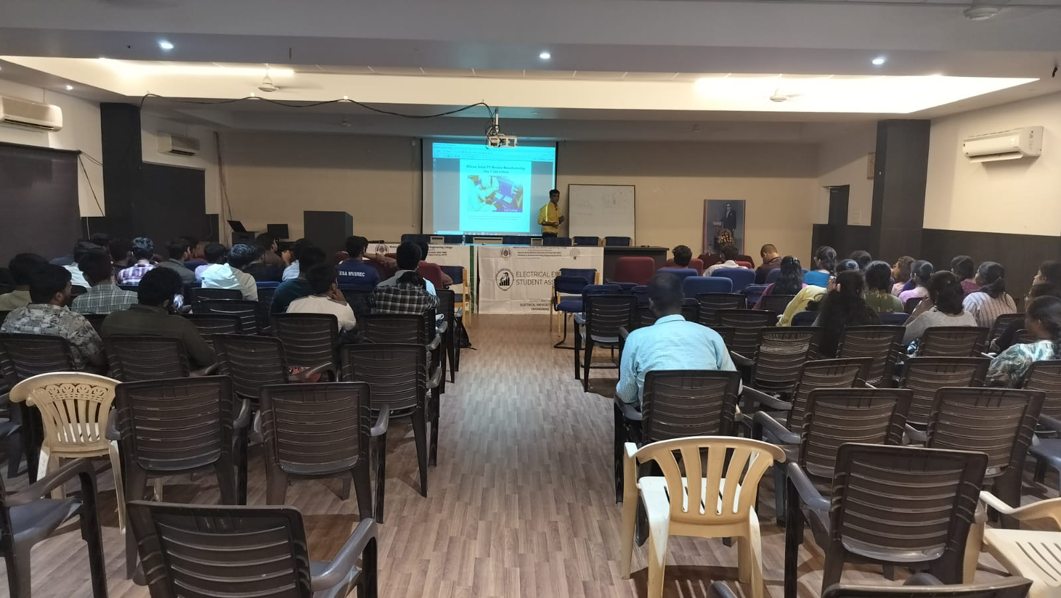
Speaker addressing the gathering on 7th October, 2023

After the session, there was a valedictory function for this five-day workshop. The faculty and students gave positive feedback on this workshop. They said that they have learned the fundamentals and designing concepts of Solar PV Plant. This workshop was very useful and all the sessions were informative. Mr. B. Rama Krishna thanked the speaker for delivering very valuable information in the session. A vote of thanks by Mr. K. Chandra Teja, IEEE MVSR PES Student Chapter, Joint Secretary, marked the event's end.

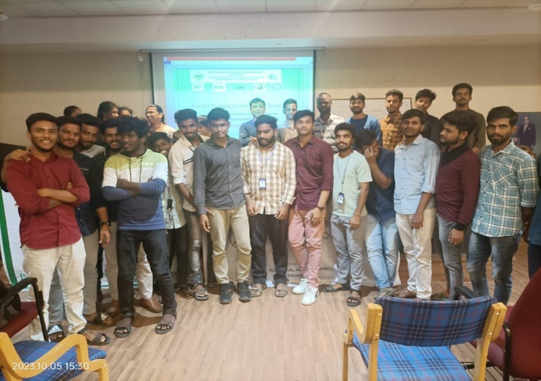
Group picture of participants along with the speaker
List of attendees:
S.No | Roll No | Student Name | IEEE ID number
1 | 2451-21-734-001 | Mohammed Awez
2 | 2451-21-734-002 | Kampa Koushik
3 | 2451-21-734-003 | Mohammed Amer
4 | 2451-21-734-007 | Kethavath Swamy
6 | 2451-21-734-012 | Golla Vinod Kumar
7 | 2451-21-734-019 | Dade Manusha
8 | 2451-21-734-020 | Mohammed Asad
9 | 2451-21-734-027 | Ramavath Ankitha | 98936794
10 | 2451-21-734-028 | Gavvala Prashanth
11 | 2451-21-734-029 | Bangla Priyamvada
12 | 2451-21-734-030 | Ulpara Bharath
13 | 2451-21-734-032 | Perla Kavya
14 | 2451-21-734-033 | Periketi Phanindra Kavi
15 | 2451-21-734-034 | Navilpakam Sri Harsha
16 | 2451-21-734-035 | Appanagari Susheshana
17 | 2451-21-734-037 | Eaga Harish
18 | 2451-21-734-303 | Yacharam Naveen
19 | 2451-21-734-304 | Bijjala Preethi
20 | 2451-21-734-305 | Racha Rajeshwari
21 | 2451-21-734-307 | Kadaboina Suma Manmika
22 | 2451-21-734-308 | Toorupati Shukraj
23 | 2451-21-734-309 | Manikyam Jyothir Adithya
24 | 2451-21-734-310 | Eruku Sai Pavan
25 | 2451-21-734-311 | Y Yashvanth Kumar
26 | 2451-21-734-313 | Sayyad Anwar
27 | 2451-21-734-314 | Gavva Pavan Kumar Reddy
28 | 2451-21-734-315 | Malthumkar Gayathri
29 | 2451-21-734-316 | Alluri Laya
30 | 2451-21-734-317 | Nagula Sanjeev Yadav
31 | 2451-21-734-318 | Chikkalgi Sri Harsha Vardhan Reddy
32 | 2451-21-734-319 | Gona Anvitha
33 | 2451-21-734-320 | Mudigonda Durgeshwara Rao
34 | 2451-21-734-321 | Govindbaksh Vijaykiran
35 | 2451-21-734-322 | Ganji Narendra
36 | 2451-21-734-327 | Hugge Ashwini
37 | 2451-21-734-328 | Roushan Kumar Barnwal
38 | 2451-21-734-329 | Bollam Naresh
39 | 2451-21-734-330 | Kudikala Chandra Teja | 99479404
40 | 2451-21-734-038 | Dusari Sai Deekshith Goud
41 | 2451-21-734-040 | Jinka Chaithanya | 98936758
42 | 2451-21-734-041 | Dyasani Advitha | 98934859
43 | 2451-21-734-042 | Ramavath Bharath
44 | 2451-21-734-043 | Mohd Anas Ahmed
45 | 2451-21-734-045 | Mohan Kumar
46 | 2451-21-734-050 | Shaik Akram
47 | 2451-21-734-052 | Paramkusam Gayathri | 98946853
48 | 2451-21-734-055 | Banavath Sree Vidya | 98934833
49 | 2451-21-734-056 | Kanugula Sravan Kumar
50 | 2451-21-734-057 | Ragula Pradham
51 | 2451-21-734-058 | Palla Laxmi Gayathri | 98946841
52 | 2451-21-734-059 | Anugu Poojitha | 98936913
53 | 2451-21-734-060 | Ajmeera Mounika
54 | 2451-21-734-063 | Gajula Bhavana
55 | 2451-21-734-064 | Vislavath Umesh
56 | 2451-21-734-065 | Jatavath Tharun
57 | 2451-21-734-066 | Sumaya Thabassum Vali | 98937346
58 | 2451-21-734-331 | Bakam Sravya
59 | 2451-21-734-334 | Ella Sushma
60 | 2451-21-734-336 | Jatavath Anil Kumar
61 | 2451-21-734-337 | Gade Swetha
62 | 2451-21-734-338 | Mallareddy Shiva Prasad
63 | 2451-21-734-343 | Chinthakuntla Nandeeshwar Reddy
64 | 2451-21-734-344 | P.Ravi Teja
65 | 2451-21-734-347 | Shaik Sohail
66 | 2451-21-734-356 | Banda Laxmi Narasimha
67 | 2451-21-734-359 | Manemoni Laxmi Bhargavi
68 | 2451-21-734-361 | Narayanadas Tarun Kumar
69 | 2451-21-734-010 | Mohammad saqib ali
70 | 2451-21-734-018 | Kotla srikanth
71 | 2451-21-734-301 | Maddur mahendar | 99460864
72 | 2451-21-734-324 | Gundarpu sandeep
73 | 2451-21-734-048 | Mudavath mallesh
74 | 2451-21-734-360 | G.Sriram
75 | EEE Faculty | Mr.B.Ramakrishna
76 | EEE Faculty | Dr.D.Harikrishna | 90436180
77 | EEE Faculty | Mr.Y.L.Narsimha Rao | 96450801
78 | EEE Faculty& HOD | Dr.C.V.Gopala Krishna Rao
79 | EEE Faculty | Mr.I.Narasimha swamy | 97981180
80 | EEE Faculty | Dr .D. Venumadhava Chary
81 | EEE Faculty | Dr. P. V .V. Rama Rao
82 | EEE Faculty | Dr. T. Chandra Shekar
83 | EEE Faculty | Mr.P. V. V. Raghava Sharma
84 | EEE Faculty | Mr. S. Shyam Mohan
85 | EEE Faculty | Mr .G. Satyanarayana
86 | EEE Faculty | Mr .N. Ravi
87 | EEE Faculty | Mr .P. B. Guru Prasanna
88 | EEE Faculty | Mr .V.Raghu Krishna
89 | EEE Faculty | Mr .L. Harshavardhan
90 | EEE Faculty | Mrs. D. Saiprasanna
91 | EEE Faculty | Mr.V. Ashok
92 | EEE Faculty | Mr.K. Rajesh Kumar

REPORTED BY:
IEEE MVSR SB

